ETL Processing Final
In this final project, you will create a complex ETL process. This activity will take you about 20 to 30 hours, so plan accordingly!

The Final consists of four Milestones:

A07 - Milestone 1: File Imports
Automate ETL from clinic CSV files to Patients database

A08 - Milestone 2: Data Warehouse ETL
Automate ETL from Patients and DoctorSchedules databases to the DWClinicReportsData database

A09 - Milestone 3: New Feature Evaluation
Automate ETL report data from DWClinicReportData to a MongoDB Atlas database

A10 - Milestone 4: Documentation
Document your ETL process and write a "Lessons Learned" paper.

Note: You must upload the new versions of the final each week to the same assignment in Canvas. Although you must upload your current milestone file each week, the assignment will only be graded once, at the end of the course!

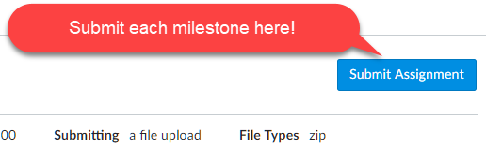

Note: Name your file as ETLFinal_YourNameHere.zip each time you upload the file in Canvas. The instruction team will be able to see all the previous versions, so there is no need to be more specific.

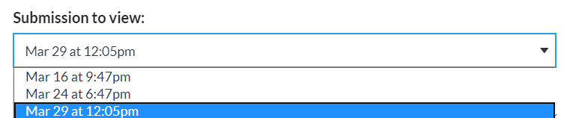

Getting Started
Currently, the business has individual clinics sending data to a corporate office by uploading CSV files each day. Those files are manually added to one of the two databases.

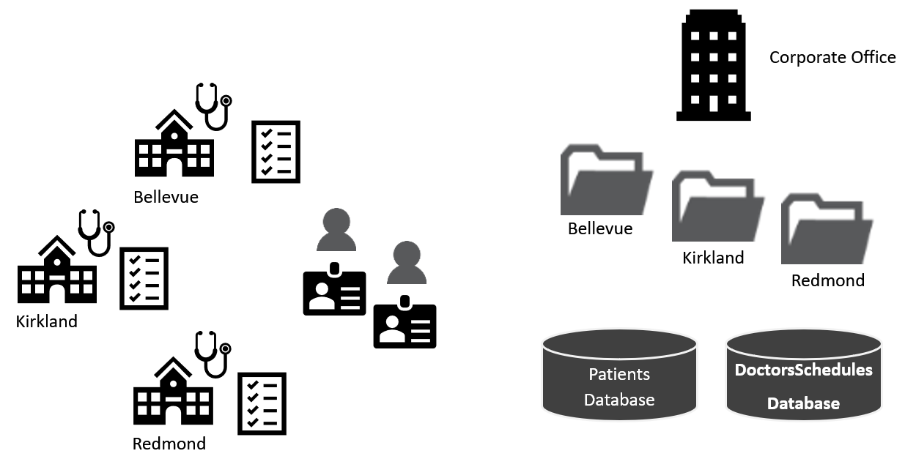

The current ETL process is entirely manual.
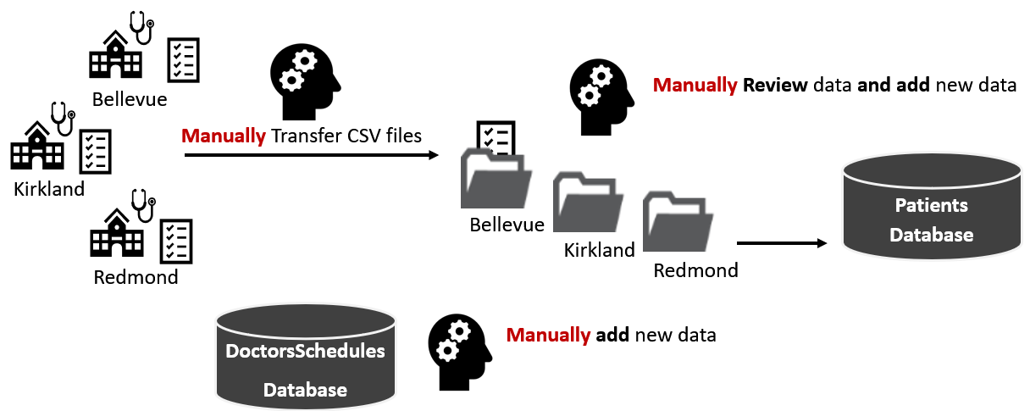

The new ETL process will include some automation. If all goes well, they may fully automate in the future.
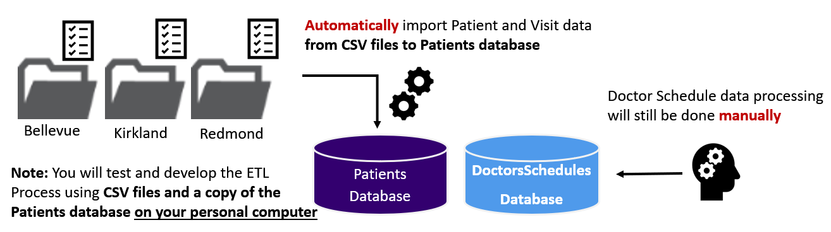

Milestone 01: File-Based ETL
The goal of milestone 1 is to automate the import of data from the CSV files into the "Patients" database. There are two sets of files in each folder, with new patient data and new visits data.

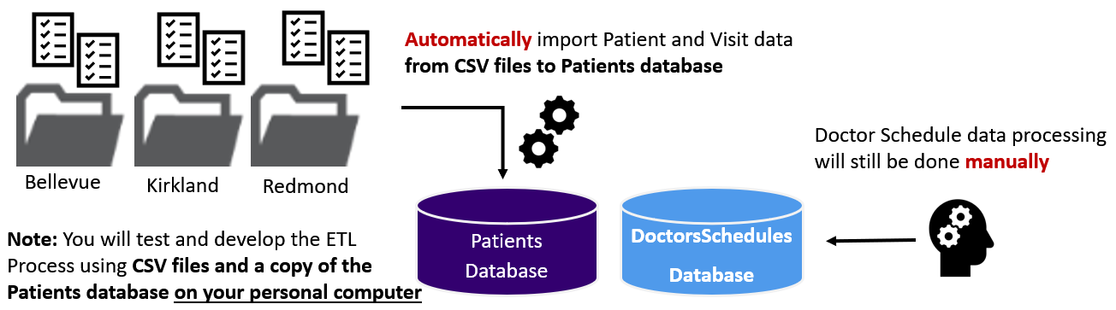
FIX Color~!
Important: You need to review and look for common issues (bad data, nulls, data types, etc.) to make your ETL process work.

Perform the following activities to complete Milestone 01.

1. Review the Daily Import Files
There are two sets of CSV files to process. These files represent data added daily to the source databases. Review each file, noting any issues in their design and data!

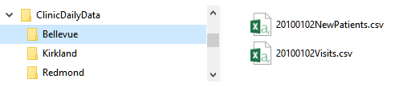
Examples of the daily data CSV files

Notes:
- You need to Flag invalid email addresses during the OLTP database import process, even though we do not use the email address in the data warehouse
- You will find addresses in the OTLP database that appear to be corrupt. However, you are NOT required to clean or flag these address
- One of the clinics is not formatting the CSV files correctly (the Clinic ID is missing)! You must figure out either a SQL or Non-SQL way to fix this

2. Create a Blank Visual Studio Solution
You are creating a complex ETL processing solution with lots of code and documentation files. You must organize these files into a single VS solution.

Important: Make sure to add all the documents, scripts, SSIS Packages, and any other files to your Visual Studio solution. If you need more help watch: Saving VS Solutions with Multiple Projects and Files

3. Create a Dev copy of the OLTP Databases
You need to attach the two source databases called DoctorsSchedules and Patients on your personal computer. These will be your developer copies of the databases. The .MDF files for each database are included with the Final's zip file. Review the tables and note any issues you find.
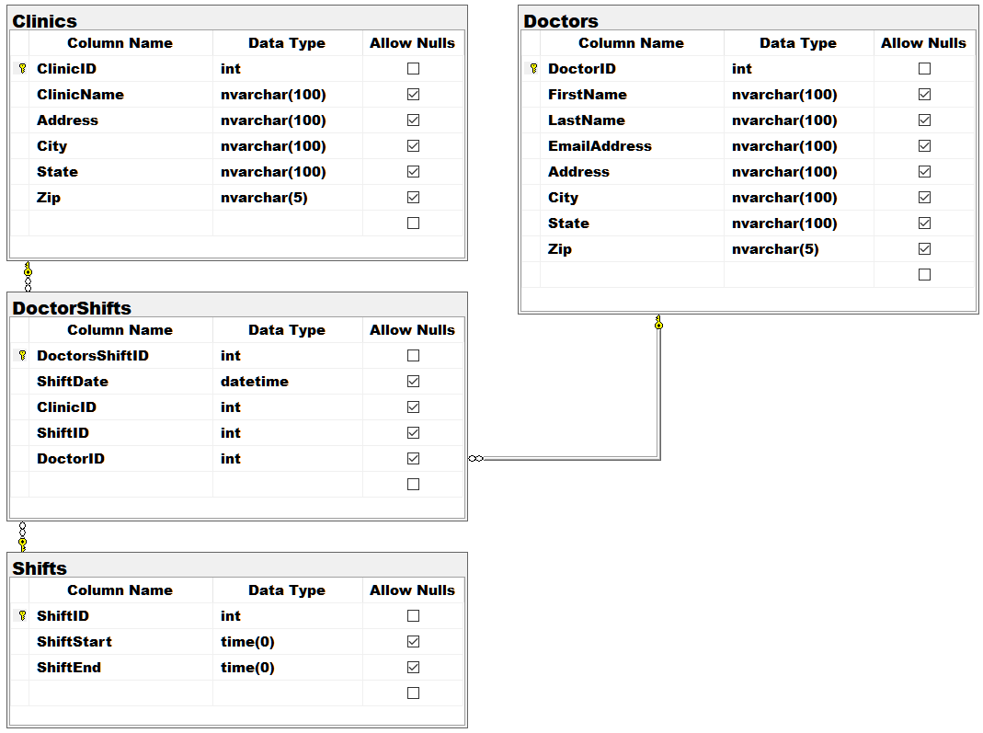
DoctorsSchedules Database

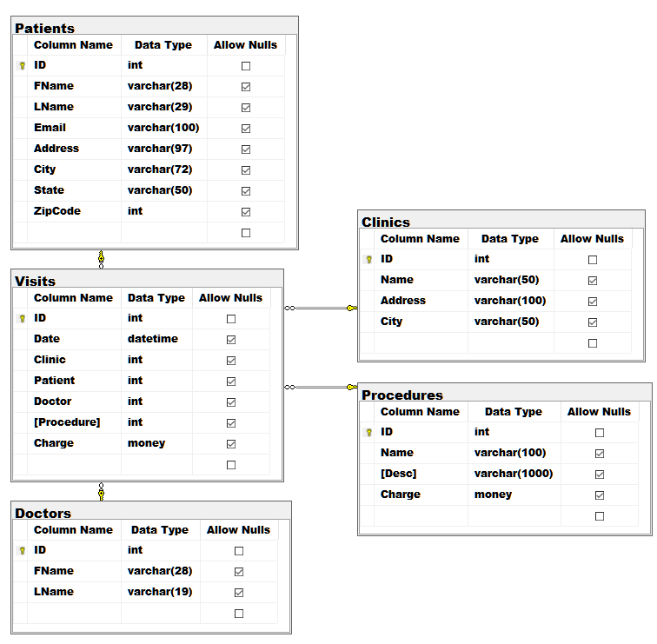
Patients Database

4. Create an SSIS Package
Create an SSIS package that imports data from the files into the "Patients" database. You can use any language and scripts demonstrated in the course, but they must run from an SSIS package. Also, all script code must be placed in script files and included in the solution.

Important: This step requires you to add a new SSIS project to your existing blank Visual Studio solution.

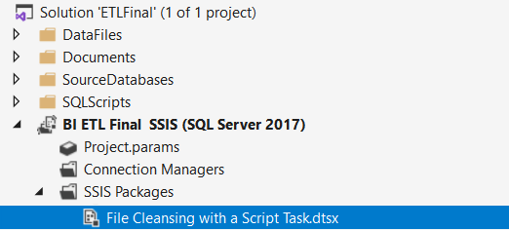

The ETL process must:
- Incrementally load the source databases with CSV data (daily).
- Flag bad email addresses using either SQL or Non-SQL processing techniques.
- Convert schedule time data to a 24-hour format
- Incrementally load the data warehouse with source database data (daily).
- Use Views and Stored Procedures when working with SQL code

Submit a BI Solution to the Canvas site
Note: You must upload the new versions of the final each week to the same assignment in Canvas. Although you must upload your current milestone file each week, the assignment will only be graded once, at the end of the course!

Milestone 02: Data Warehouse ETL
The goal of Milestone 02 is to create an ETL process between the "DoctorsSchedules" and "Patients" OLTP databases and the "DWClinicReportData" OLAP database. The two OLTP databases are on different servers, one hosted on Azure and the other on the UW network.

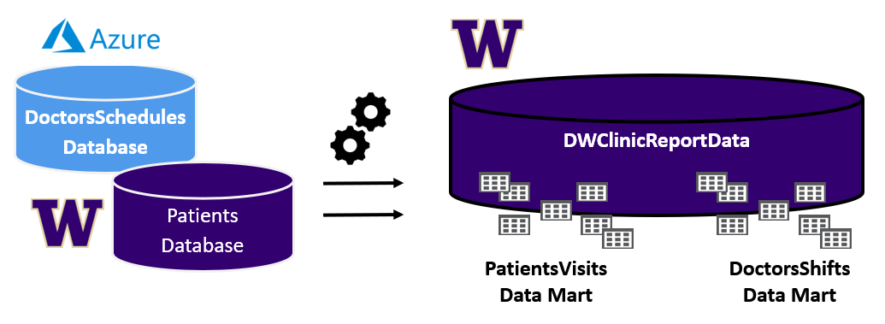
Notes:
- The DoctorsSchedule database is on our class's Azure cloud Server
- The Patients database is on our class's UW Server
- DWClinicReportDataYourNameHere is created on our class's UW Server

Perform the following activities to complete Milestone 02.

1. Create a Data Warehouse
I have given you a data warehouse database script to create your personal data warehouse destination database.

Important: You must change the SQL Script to include your name before you run it on our UW server (
is-root01.ischool.uw.edu\BI).

Create Database DWClinicReportDataYourNameHere;
go

Review this database design, noting the two DataMarts (A and B). Also, note that DimPatients is a Type-2 SCD design, but all other tables are a Type-1 SCD design.

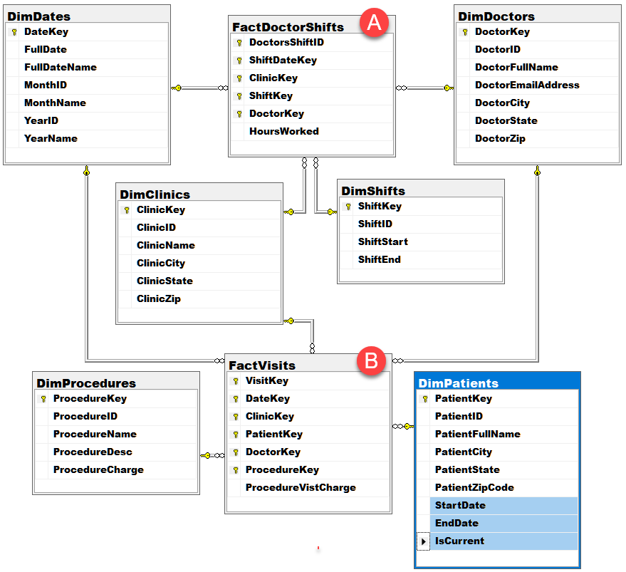

Start the Solution Developer Document in Excel
You need to document your development of the BI solution using a developer spreadsheet. Use the Excel spreadsheet I have provided as a starting template. Change and fill the spreadsheet with the source, destination, and transformation metadata as needed to describe your ETL process.

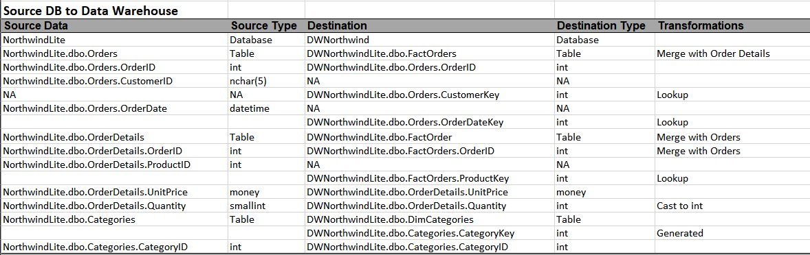

Create an SSIS Package
You need to create an SSIS ETL package to perform the ETL processing from the OLTP databases into the Data Warehouse database. You can use any language and scripts demonstrated in the course, but they must run from an SSIS package. Also, all script code must be placed in script files and included in the solution.

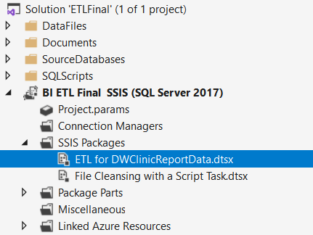

The ETL process must:
- Transformations can be done using SQL or Non-SQL processing techniques.
- Incrementally load the data warehouse with source database data (daily).
- Use Views and Stored Procedures when working with SQL code.

Submit a BI Solution to the Canvas site
Note: You must upload the new versions of the final each week to the same assignment in Canvas. Although you must upload your current milestone file each week, the assignment will only be graded once, at the end of the course!

Milestone 03: Non-SQL ETL
The goal of Milestone 03 is to create an ETL process between the "DWClinicReportData" database and a MongoDB database hosted on Atlas.

Create a MongoDB Database
You need to create a MongoDB database on Atlas to host the new report documents. Copy the data in the "DWClinicReportData" database to the ClincReportsData database.

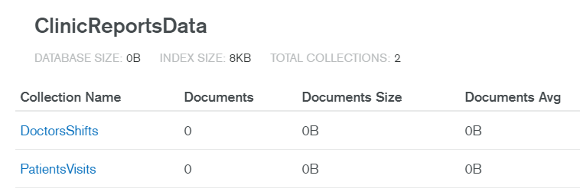

We will use Python to Extract, Transform, and Load data from the data warehouse to Atlas

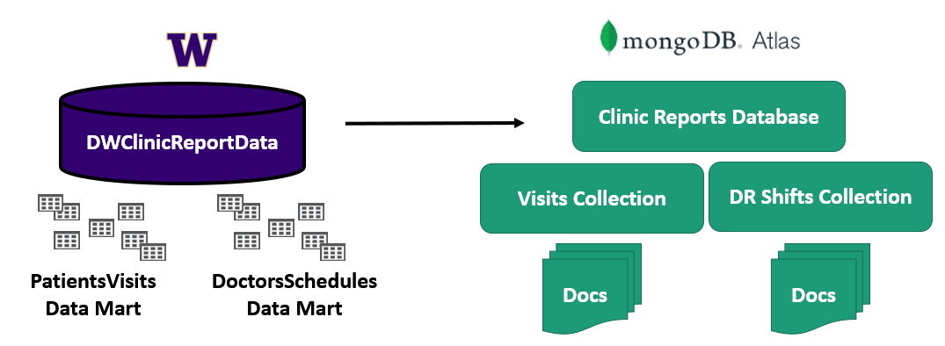

Create an SSIS Package
Create an SSIS package that imports data from the data warehouse into the document database. You can use any language and scripts demonstrated in the course, but they must run from an SSIS package. Also, all script code must be placed in script files and included in the solution.

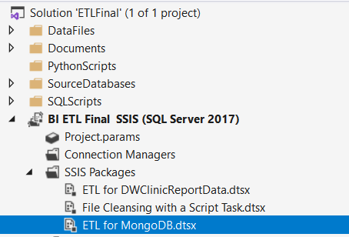

Note: You must upload the new versions of the final each week to the same assignment in Canvas. Although you must upload your current milestone file each week, the assignment will only be graded once, at the end of the course!

Milestone 04: Documentation
The goal of Milestone 04 is to complete the BI solution by adding two sample reports and documenting your solution.

Create Excel Reports
You need to create two Excel reports showing data from both the data warehouse and the MongoDB databases.

Notes:
- Please use one Excel report for both reports (on different tabs)
- Your reports must have a basic header and formatting (name, date, etc.)

Create a Technical Overview Document
At that point, you need to update your Excel development document to accurately record the objects in your BI solution. The reason for this is that things tend to change as you go through the creation of any BI Solution, and you need to make sure your final documentation reflects what was built.

Next, you need to create a technical document that describes the ETL process you have created. Any reader should be able to read your documents and understand what the solution's components are, why they are used, and how they are used.

Write a One-page Review
Write a paper that outlines what you have learned in this class. The review helps both you and me to understand your progress in this class. You may be surprised to see that this process solidifies what you have learned (or at least other students have told me it does!) There is no need to make this an exhaustive coverage of what you did but do make the paper at least a few paragraphs of well-written text.

Submit a BI Solution to the Canvas site
Each week you configure and test your solution, ZIP the entire BI solution folder and upload it to the Canvas web site. Remember that you will have placed all the files for the ETL scripts, SSIS, Excel ETL and Word docs into one solution folder. Zip everything up into one Zip file and submit it to Canvas.

Note: You must upload the new versions of the final each week to the same assignment in Canvas. Although you must upload your current milestone file each week, the assignment will only be graded once, at the end of the course!

